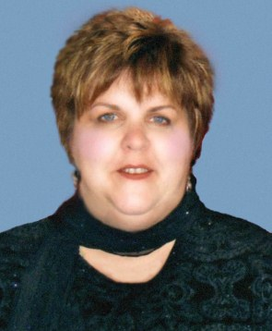
A native of Virginia, Linda Carr-Kraft is the great-great-great-great granddaughter of Martha Jefferson Carr, the younger sister of the third president, Thomas Jefferson. Martha married Thomas Jefferson’s childhood friend, Dabney Carr and Martha and Dabney are buried next to Jefferson at Monticello. Dabney was elected to the Virginia House of Burgesses and proposed the resolution that created the Committees of Correspondence on March 12, 1773. When Carr died in May of 1773, his wife Martha and their six children went to live at Monticello, where Jefferson served as guardian to his nieces and nephews. Martha continued her husband’s endeavor to free the colonies from England by aiding revolutionary soldiers and delivering supplies to the men. She was declared a “patriot” by the D.A.R for her courageous efforts during the war.

Linda currently lives in Richmond, Virginia with her husband, Sam, where she is a clinical audiologist. She is also a founding member of the Monticello Community which includes all of the descendants of those who worked or lived at Monticello during Jefferson’s lifetime. She is committed to the efforts of those who work towards reconciliation between the descendants of slaves and the descendants off slave owners in the hopes of making the dream of Dr. King become a reality.

Linda’s family is interwoven with many of the early families of Virginia and the resulting family tree has given her a very personal insight into our nation’s history, and especially the many strong women who became our “founding mothers”. She is very pleased and honored that she will be able to acknowledge the efforts of her ancestor, Martha Jefferson Carr, and as well as the many brave women who served our country in its infancy.

